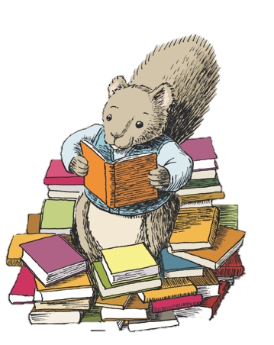

Spring 1st Half Term
English To be completed by Monday 16.1.23  Look at the list of Year 3/4 common exception words you have in your reading folder. On the bank paper provided, create mnemonics for 5 words you think are tricky to spell. A mnemonic is a way of remembering spellings using the first letter in the word e.g.  BECAUSE  Big Elephants Can Always Upset Small Elephants. | Science To be completed by Monday 23.1.23  On the blank paper provided, design a bright, eye catching and informative poster about keeping safe near electricity. Think back to what we learnt in class and also BBC biteszie has a great page of resources to help should you need some ideas. | Reading To be completed by Monday 30.1.23  10. Create your own blurb for the book you have read.  Remember you are trying to sell the book to other people, be descriptive in your writing.  VCOP - circle the punctuation in yellow
Maths To be completed by Monday 6.2.23  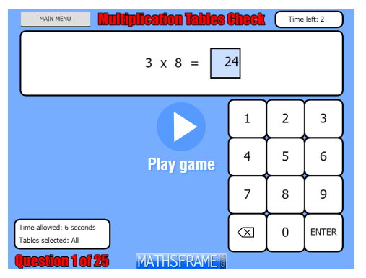  Google - ‘mathsframe Year 4 multiplication check’. On a computer/phone/tablet complete the game of 25 questions. You have 6 seconds for each question. Try this every day for a week and keep a record of your score to show Mrs Redman and Mrs Bishop. Can you improve as the week goes on? | History  To be completed by Monday 13.2.23  Using a computer, research some Anglo-Saxon artefacts.  Once you have found them, draw a picture of three different artefacts.  When you have completed your pictures, predict what the artefacts might have been used for during Anglo-Saxon times. | Reading  To be completed by Monday 20.2.23  Imagine you and the main character in the book are having a conversation.  Write down your questions and the detailed responses their character would give.
Spring 2nd Half Term
Reading To be complete by Monday 6.3.23  Write a description of the setting in the book you are reading.  Remember to use a wide variety of adjectives in your description. VCOP – Underline the adjectives in red | Maths To be complete by Monday 13.3.23  Practise your fluency of multiplying a 3 digit number by a single digit number. Roll a dice 4 times to generate a calculation e.g. 432 x 6 Use the grid or column method written like we have in class. Record your work on the square paper provided. Try to do at least 10 calculations. | Geography To be completed by Monday 20.3.23  Use a map, atlas or the internet to find two different types of settlements (counties/villages) within Northumberland. Then find out more about the two settlements, write down:  - What is the population within this area?  - What transport does the settlement offer?
Reading To be completed by 27.3.22  Find a recipe and bake some easter goodies for your family. Read and follow the instructions very carefully. There a of child friendly recipes on this website:  https://www.bbcgoodfood.com/howto/guide/fun-easter-projects-kids Using the lined paper provided to collect as many imperative verbs as you can from your recipe e.g. fold, whisk. Why not email your teachers a photo of your finished item sarah.redman@school360.co.uk or  emma.bishop@school360.co.uk | Over the Easter Holidays Please try to:  Practise your times tables as much as you can.  Practise reading and spelling Year 3 and 4 Common exception words which are in this reading pack.  Read a little bit (if only 5 minutes!) Every day.  Watch newsround to keep up to date with the current news.

